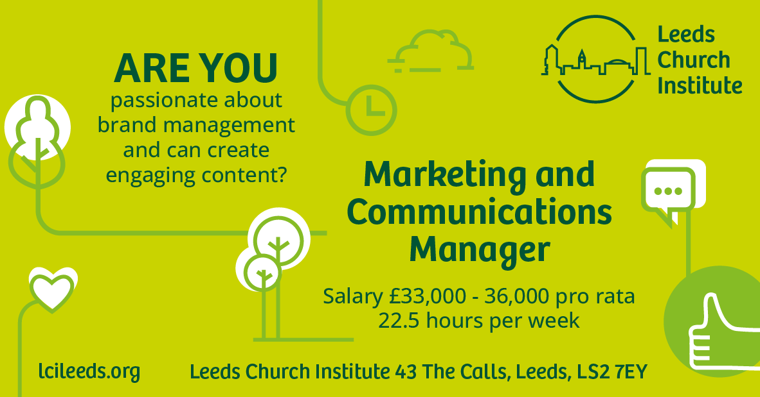

Thank you for your interest in the role of Marketing and Communications Manager at Leeds Church Institute.

Before you apply, we invite you to have a good look at our website to learn more about who we are and what we do, as well as our social media profiles; Facebook page, Twitter feed and Instagram

If you would like to arrange an informal conversation about the role with our Director, Helen Reid, please contact teamassistant@leedschurchinstitute.org

In this pack you will find the following information:

- Background information on Leeds Church Institute
- Background to the Marketing and Communications Manager role
- The recruitment process and dates
- The job description and person specification
- Link to the application form
- inclusion and diversity monitoring form (optional)

Background

‘Learning for a faithful city’ is at the heart of Leeds Church Institute’s vision. We promote learning and cooperation among churches and wider Leeds society for the Common Good.

Our activities are:

- Events, publications, media, arts and research that generate theological
conversations and provoke thinking on faith and justice
- City engagement that supports the contribution of diverse Christians in city life
and nurtures innovative ideas that bring about greater justice for all in Leeds
- An ethically organised charity, run in accordance with our Memorandum and Articles, and the Charity Commission rules

Until the pandemic hit in March 2020, a significant focus of LCI’s time and resources was dedicated to running a busy Learning Centre and maintaining a substantial property. In November 2020 a decision was made not to re-open the Learning Centre and in March 2021 to sell the premises. One consequence of these decisions was a move to smaller and more sustainable premises which has freed up resources to focus more directly on implementing our vision for our educational work and city engagement.

A five year extended scheme of work began in January 2023 to implement this reinvigorated vision. Three new staff roles (Faith and Creativity, Faith and Racial Justice, Faith at the Margins) were recruited Sept-Nov 2022 in readiness for this work. Alongside the creation of these new roles, there has been a Communications Review which incorporates building on what was learnt during the pandemic and strategies for working with a larger staff team. Key recommendations are to develop the brand of LCI, include specific elements of marketing in the work, and transfer the work from a freelance consultant to the staff team.

The flow of responsibilities is represented diagrammatically:

LCI Council
Director
Faith & Creativity Lead
Faith & Racial Justice
Faith at the Margins
Team Assistant

Marketing and Communications Manager

The recruitment process - what to expect:
The application form and (optional) inclusion and diversity monitoring form can be downloaded at www.lcileeds.org

Applications should be sent by email to teamassistant@leedschurchinstitute.org before 12pm noon on Thursday 2nd March 2023.

The application form asks for your personal details, preferred contact number, confirmation that you are eligible to work in the UK and whether you need any adjustments to enable you to physically attend an interview. These personal details will be separated from your main application information before sending to the shortlisting panel.

In addition to the application form there is an anonymised monitoring form you are invited to complete and return. Completion of this is voluntary but helps us to meet the aims and commitment of LCI to equality and build an accurate picture of the candidates we are attracting in relation to encouraging equality, inclusion and diversity. This form is not processed alongside your application and remains anonymous.

Shortlisting will take place on Friday 3rd March 2023. You will be contacted by telephone on Friday 3rd March 2023 to confirm if you are to be invited for an interview. If you are unsuccessful, you will also be contacted and given the opportunity for feedback on your application if requested. Interviews will take place at the LCI office on Friday 10th March 2023. This will be a panel interview with an opportunity to make a presentation.

Marketing and Communications Manager: Job description
Role summary:
To develop, implement and deliver on the marketing and communications strategy for LCI. To manage the brand, promote the organisation and support all engagement activity across the LCI themes including the website, social media, and events.

Terms and Conditions | Location: This role is based at Leeds Church Institute  Hours: 22.5 hrs per week (Part Time)  Salary scale: £33-36,000 pro rata (depending on experience)
Reports to | Faith and Creativity Lead
Principal areas of responsibility:
Own the marketing and communications strategy
- Create channel plans and campaigns to build awareness and promote LCI across the city
- Build relationships and contribute to creating new opportunities for engagement activities
- Write / prepare material for articles, blogs, events and statements, consulting as appropriate with the Director and LCI Leads
- Take interest in and understand the charitable and faith-based environment in which LCI exists
- Engage with press, PR, and educational research organisations
Content – develop and engage
- Create persuasive and compelling copy and content to engage audiences
- Lead on the use of our social media channels and social media tools to reach and persuade our stakeholders, partners, and members to attend events, read our resources and encourage new membership
- Take a lead on managing the website, including liaising with technical specialists and developers
Research and Insights
- Analyse the impact of marketing and communications strategic objectives and actions to improve communications
- Design and implement feedback and evaluation systems
- Liaise and engage with research, educational and other relevant organisations in collaborating on and promoting, sharing, and developing research and resources
- Use local, community-based research to ensure initiatives are appropriately informed and contextually sensitive, and keep up to date with wider research
- Develop contacts with a range of organisations in Leeds to develop networking and the profile of LCI engagement
Maintaining LCI ethos:
- Demonstrate the behaviours named as reflecting LCI ethos in carrying out this job description
Any other duties which are commensurate with the scope of the role and effective operation of LCI.

Person specification
Essential

- Demonstrates passion and enthusiasm for, and in sympathy with, the aims and ethos of LCI
- Understanding, adherence and/or development of brand guidelines and brand guardianship
- Knowledge of Content Management Systems and experience of website and digital development
- Verbal and written communication skills; able to produce engaging copy, proofread and give clear presentations
- Relationship building skills
- Able to work effectively as part of a team
- Relevant Marketing, Comms or Digital Marketing education and training qualification or experience
- Working knowledge of Eventbrite, Mailchimp and other marketing support systems
- Demonstrates sympathy with and an understanding of Christian belief

Desirable
- Experience of working in a charity or educational setting
- Experience of or qualification in PR, Events or Social Media
- Experience in designing / delivering informal educational programmes

Maintaining the LCI ethos
All staff are required to demonstrate the behaviours named as reflecting LCI ethos in carrying out their job description
Core Value | Observable Behaviours
Learning, theological reflection & dialogue | - Reflective practice  - Sharing knowledge, expertise and ideas with others  - Enthusiasm for exploring new ideas/ subjects and extending personal knowledge  - Participating and contributing to discussion / exploration of theology/ ideas / subject areas with others in the team  - Asking questions and actively listening to answers  - Reads / researches different views and opinions  - Promotes knowledge and information sharing  - Signposts others to resources
Hospitality & service | - Welcoming and friendly to visitors, partners and clients  - Anticipating and providing for the potential needs of visitors / clients / partners  - Willingly helping with whatever needs to be done to make an event run smoothly or a visitor / client feel more comfortable  - Going the extra mile to be hospitable
Partnerships for seeking the Common Good | - Looks for potential opportunities to partner in line with LCI charitable aims  - Relational approach developing conversations with people encountered through the course of daily activity contacts / building networks  - Collaborating but not duplicating
Acting and planning with long-term awareness | - Seeks a joined up approach, ensuring plans / projects are in line with LCI objectives and in relation to the portfolio of other initiatives underway  - Listens to and learns about plans / strategies of local partners and churches across the city to inform LCI longer term plans  - Looks to maintain awareness of developing thought and practice in relation to the LCI themes and how their specialist area needs to adapt or develop
Importance of arts and creativity | - Understands the value that art and creativity brings to communities and city life  - Appreciates the variety / different expressions of art and the culturally diverse views of and approach to art
Stewardship with good value for money and spending money locally | - Maintains an outcomes focused approach, consistently following through on projects or initiatives so that resources used yield the benefits planned  - Seeks to procure local input to projects and initiatives
Acceptable risk for nurturing new ideas and initiatives | - Open to innovation and exploring new ideas with colleagues  - Commitment to assessing levels of risk associated with new ideas and evaluating implementation and impact
Commitment to environmental concerns | - Seeks with team colleagues to promote green working practices (e.g. conserve energy, paperless office, encourage green vendors)  - Collaborates with the team and partners to explore improving environmental awareness / action in projects LCI supports and more widely in the city of Leeds  - Promotes the importance of environmental action as a key issue for faith communities / ecumenical action
Equality of opportunity  and access for all which avoids any discrimination | - Value and appreciate difference  - Be known for treating everyone with kindness and respect  - Promotes the value of working with others / diverse groups  - Build awareness of unconscious bias in systems / approach etc and share in developing solutions to avoid discrimination.

